**What is Spring HATEOAS**

What is Spring HATEOUS and what is the use of it?

The main moto to use Hateoas to expose our rest end point as part of response to client

Like you know the development process

Normally when MW people developed there service then they need to provide exact endpoint URL and Request Body for integration via any media like mail etc.

Sometimes we may send wrong URL for wrong end point it happens unknowingly.

So here UI Team depends on Service people, so how to overcome this issue

That’s why spring came up with Hateoas concept.

Here UI team no need to wait, when they will ask for Endpoint URL. Just inform them hey call the existing API and at response am giving related link so go ahead and integrate with that.

For EX:

Assume I have a requirement where we have to display all user present in my database in tabular format

And in name column just add a hyperlink through which if I click on that particular name it will display that specific user information in UI

So for this requirement I need to develop 2 API .one is getALLEmployee () and one more getEmployeeByName ()

So here am done with both API development and give first API to UI integration. So here to integrate and test for first API it depends on second API getEmployeeByName () so instead of give 2 API info separately I just give them hey take First API and then in response itself I provide inter link to connect second API just add that text as hyperlink using <a href=”link”></a>

Like below

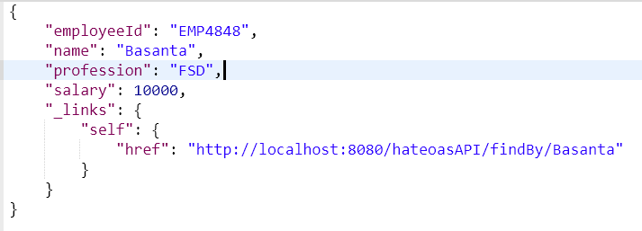

Which is easier to save dev time.

Hope this you will enjoy, it’s not a big enhancement of spring framework we can do it manually like we can create one more field in our response class

Like private String URL;

In this URL attribute we can hardcode our URL, and for every object we need to set URL manually which seems boiler plate code.

But spring provide this features to achieve using inbuilt API Hateoas .without boiler plate and no hardcode just give root url to Link object then ControllerLinkBuilder class will take care of it to generate hypermedia link as part of json response

Thanks,

**Basanta Hota**